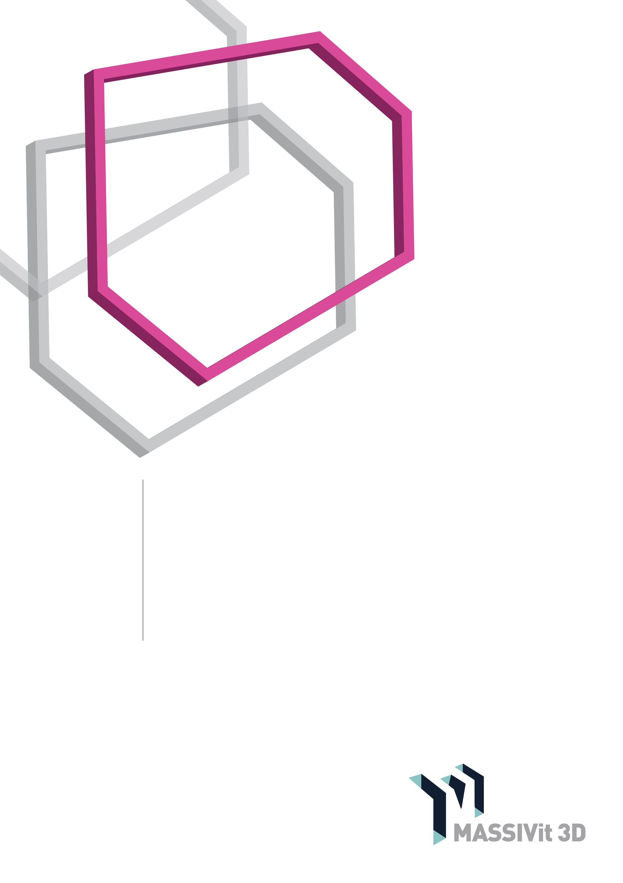

Massivit

HOW-TO GUIDE

Basic Model Finishing Procedures

[www.massivit.com](http://www.massivit.com)

The information provided in this document is believed to be accurate and reliable. However, Massivit 3D assumes no responsibility for the use of this document or for the performance of any materials mentioned. Massivit 3D reserves the right to make changes to this document or any material included in it at any time and without notice.

Published on December 2017

© Copyright MASSIVit 3D 2017

CONTENT

Introduction 5

Working Tools 5

Safety 5

Removing Slight Imperfections 7

Closing and Opening Holes in a Model 11

Gluing Parts Together 14

Summary 15

INTRODUCTION

The Massivit 1800 3D printer produces large scale, light weight and hollow objects that are used for creating eye-catching visual communications. The following document is designed to assist Massivit 1800 3D printer owners and operators in preparing the model for the next stages of painting or coating.

Note: In some cases models are designed to be lit from inside, which may entail some changes in the steps described in this guide. For those cases, please refer to the relevant How-to Guides, or contact Massivit service personnel.

The specific operations that are covered in this application note are:

* Post-print cleaning of the model, such as the removal of brim and support structures
* Fixing slight printing imperfections and filling holes
* Attaching parts of a model together using best practices

This document does not include decorative finishing operations, such as painting or coating the model. For information about those operations, please refer to the relevant How-to Guides, or contact Massivit service personnel.

WORKING TOOLS

A basic set of tools is imperative for performing the finishing activities outlined in this document. Please make sure you have them accessible before starting work. The tools can be electric or pneumatic although it is easier to work with pneumatic tools as they weigh less and are less prone to vibrations.

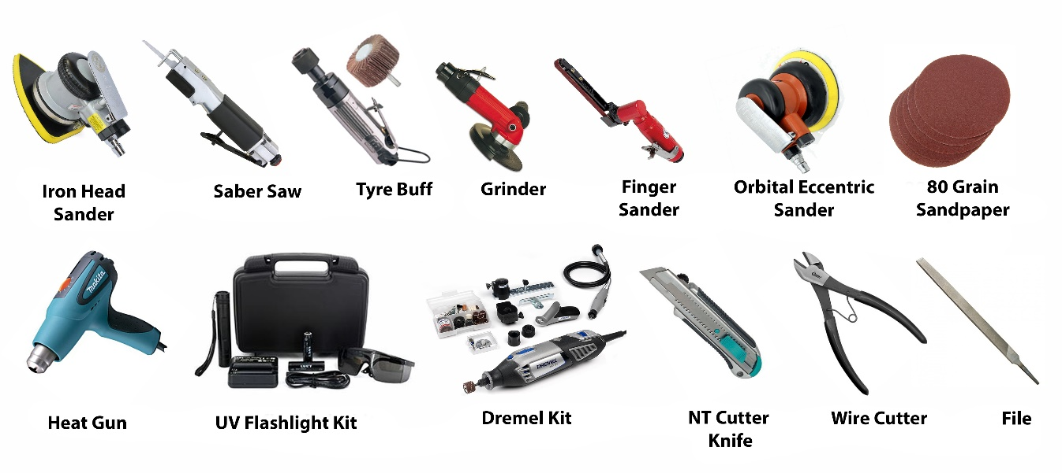These are the tools that will be mentioned in the subsequent parts of this document (the pictures are for illustrative purposes only and do not imply the recommendation of a specific manufacturer or model). *See figure 1.*

***Figure 1***

SAFETY

Note: Working tools should be used only by experienced personnel and in accordance with the manufacturer’s safety instructions

It is imperative to wear a face mask in order to prevent the ingestion of plastic particles when cutting and sanding cured Massivit Dimengel (or any other type of plastic).

Always wear protective glasses/safety goggles to prevent plastic splinters or dust from injuring your eyes when cutting the model.

Always wear UV protective goggles, gloves, and clothing that completely covers your body, such as a long-sleeved shirt and long pants, when using the UV flashlight for curing raw gel.

Working tools should be used only by experienced personnel. When using any type of equipment, it is imperative to use it in accordance with the manufacturer’s safety instructions. Do not use a product without reviewing the safety instructions.

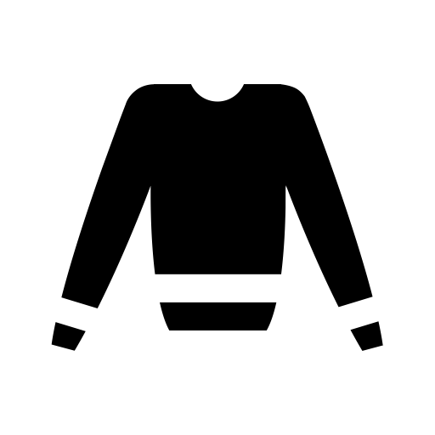

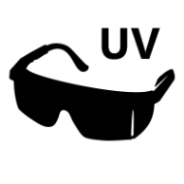

REMOVING SLIGHT IMPERFECTIONS

Sanding the whole surface of a large model to make it smooth is not only tedious and time-consuming but also may compromise the strength of the model walls. To achieve a smooth look for your whole model, the best practice is to coat it.

For removing local imperfections, sanding with sandpaper is the preferred solution.

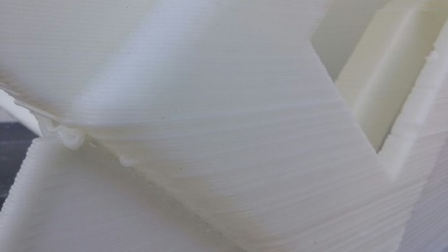The sanding can be done with a variety of polishing tools. It is advisable to work with 80 or 60 grain sandpaper. Choose the tool you use according to the area that you need to polish. For example, an orbital sander is best for larger areas while for smaller areas it is recommended to use tools that can enter narrow or rounded spaces. *See figure 2.*

***Figure 2***

### Removing Brim

In many cases, successful model printing requires the production of a “brim”, a smooth surface strip at the bottom of the model, that improves the adhesion of the model to the print bed surface.

The brim is usually located on both sides of the model wall, on the inside and outside of the model. However, only the outside brim needs to be removed. The internal brim should be kept as the increased surface area makes it easier to glue model parts together. *See figure 3.*

Note

If the model will be coated, it is very important to remove prominent defects before starting the coating process.

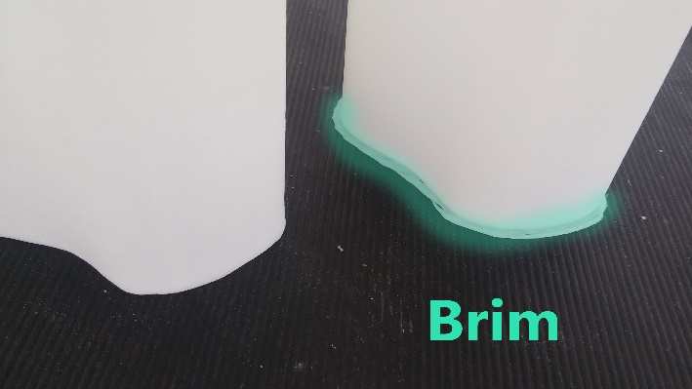

***Figure 3***

After removing the brim with a cutter, the area should be sanded with an orbital sander or file. If the surface is very complex, you may want to heat the area with a fan and cut the brim with a sharp NT cutter knife. *See figures 4-6*.

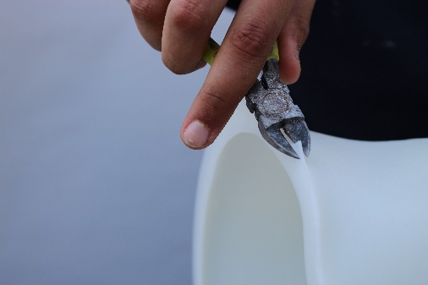

***Figure 4: Removing the brim with a cutter.***

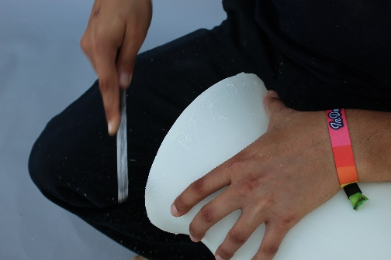

***Figure 5: Removing the brim with an NT cutter knife.***

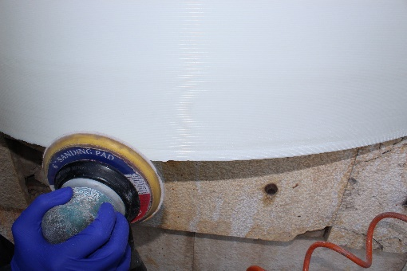

***Figure 6: Sanding with orbital sander after removing the brim.***

**Removing Support Structures**

When printing a difficult model, an external support structure may be added using the slicer software. These functional structures are not an integral part of the model itself and must be removed post-printing.

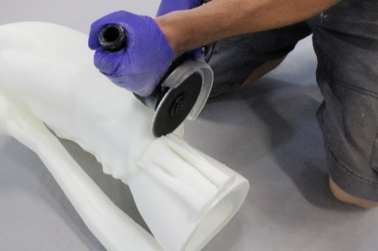There are several types of support structures and for each one we recommend a slightly different method of removal. The general guideline for removal of support structure is to avoid, as much as possible, creating shock waves (e.g. a strong blow to the support element) that may impact or fracture the model. Always handle your 3D-printed model with care.

### Support Poles

***Figure 6***

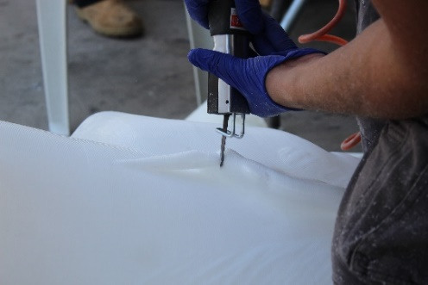Support poles are columns that extend from a hanging area on the model downward to the model body or to the print-bed. This type of support structure is the hardest to remove, due to its typically larger size. To remove support poles, use a grinder or saber saw and then polish the area. *See figures 6 and 7.*

### Support Lines

Support lines are columns that extend from a hanging area on the model to its sides. This type of support structure is easy to remove. To remove the support lines, use a cutter and then polish the area afterwards. *See figure 8.*

figure 8 - support lines removal

***Figure 7***

### Support Ribs

Support ribs are additional “walls” that are added to the model during slicing to add strength and reduce deformation. The support rib can be often easily separated from the model, even manually. *See figures 9-10*.

When the model is based directly on top of a support rib, the connection may be stronger and not easily removed by hand. In such cases, the support rib should be removed using a cutting tool such as a cutting disk or a saw.

***Figure 9: A support rib***

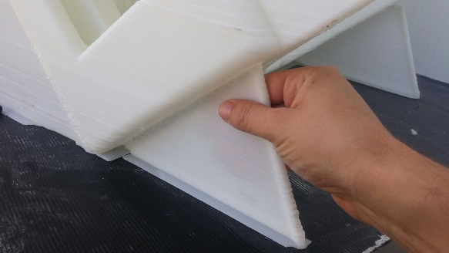

***Figure 10: Removing a support rib by hand***

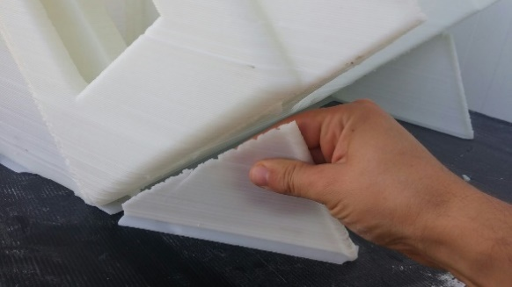

# CLOSING AND OPENING HOLES IN A MODEL

**Closing Small Holes**

Tip:

After printing, save and store leftover gel material from the gel pail for closing small holes. The leftover gel should be stored in a sealed container that is protected from light.

There are often small holes in the model due to the nature of the printing process, especially at the very top the model. These small holes are created when the Massivit printer tip reaches its minimum printing size. These holes can be very easily closed using a very small amount of Massivit Dimengel printing gel.

When a small hole occurs, place a small amount of Dimengel on top of the hole and then wipe the area to keep it smooth. Because of the gel’s viscosity, it will take it a few seconds to fall through the hole. Before this occurs, quickly cure the raw gel area with a UV flashlight. The gel will solidify and close the hole. *See figures 11-13.*

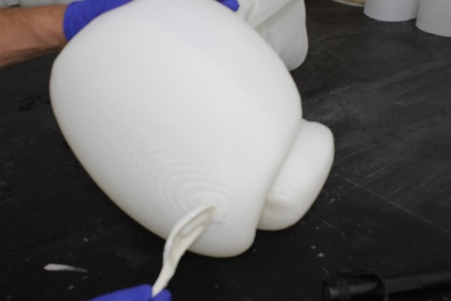

***Figure 11: Apply a small portion of Dimengel on top of the hole.***

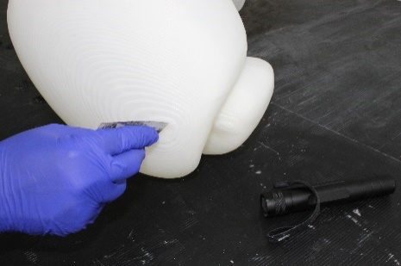

***Figure 12: Wipe the area to keep it smooth.***

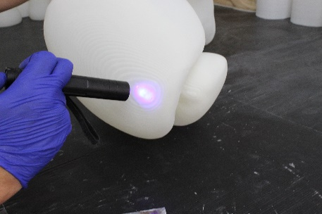

***Figure 13: Quickly cure the raw gel area with a UV flashlight.***

# **Closing Large Holes**

Note: There are many suitable UV flashlights on the market at a wide range of prices.

Please verify that the flashlight you are using supports the 395-nm wave length.

Consult the flashlight instruction booklet regarding the proper distance of the flashlight from the model, and other usage information.

For additional specifications or for purchasing a UV flashlight from Massivit, please contact [support@massivit.com](mailto:support@massivit.com)

**Large holes may occur if the model is accidentally damaged after printing. Closing large holes is very similar to the closing of small holes, but the hole should be closed from the inside of the model using cello tape before applying the Dimengel. The cello tape will form a base for the Dimengel and prevent the gel from falling through the hole before it is cured with the UV light.

*See figures 14-17*

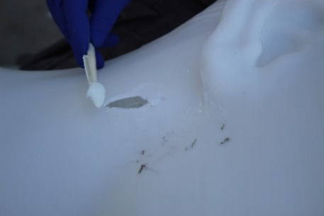

***Figure 14: Apply cello tape on the hole from the inside of the model***

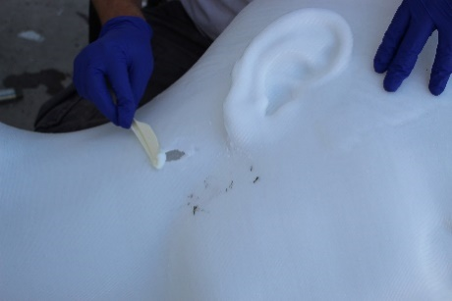

***Figure 15: Place a small amount of Dimengel on top of the hole.***

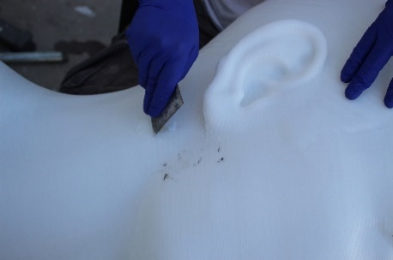

***Figure 16: Smooth the gel and wipe away the excess.***

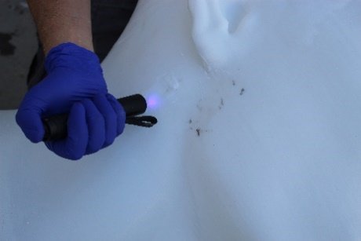

***Figure 17: Cure the raw gel with a UV flashlight. Use protective googles and clothing.***

# **Making a Hole**

Occasionally a hole may be required to insert a metal construction, polyurethane foam, or other substances that cannot be inserted into the model using existing openings.

To make a hole, drill a small hole using a drill bit, and then insert a saber saw into the hole and cut away additional material to reach the desired diameter or shape. *See figures 18-20.*

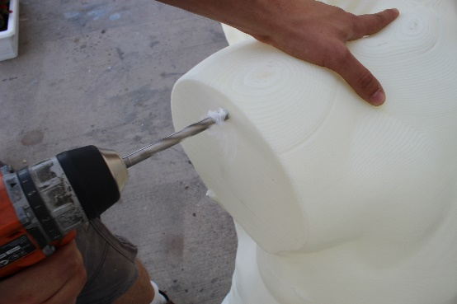

***Figure 18: Drill a small hole.***

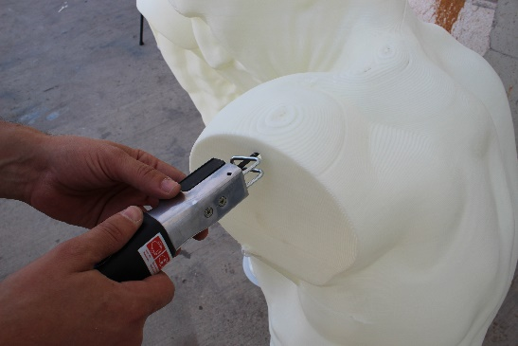

***Figure 19: Insert a saber saw into the hole.***

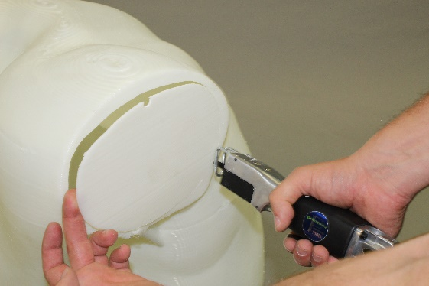

***Figure 20: Cut the hole to the desired diameter or shape.***

# GLUING PARTS TOGETHER

Note:

To avoid unnecessary movement and to allow proper adhesion between the parts, assistance should be used when gluing parts together.

3D-printed models are often too large to be printed in one piece or they are printed in parts for a variety of reasons: esthetics, faster production, more efficient use of gel, or optimizing printer usage. In such cases, the printed parts must be glued together to complete the model.

Begin by removing any external brims or support structures and fill any unwanted holes as described above. Then ensure that the two parts fit together firmly.

Massivit Dimengel makes an excellent adhesive for gluing model parts together. Place the gel on the entire contact area and, if possible, on the inside brim as well. Then place the parts together using assistant.

Next, add a bit more gel at the connection area–the external side of the two parts. Ensure that the space between the parts is completely filled while the gel is still soft, and then wipe away any excess material. Using the UV flashlight, expose the freshly applied gel for a minute over the entire connection area, until the gel hardens. Repeat this procedure until the entire part is firmly bonded. After the parts are glued together, polish the area to hide the connection area. *See figures 21-23.*

Note:

If the area you wish to glue will support a lot of weight or pressure, a metal construction must be inserted prior to gluing.

For more information, see Massivit’s application notes about metal constructions in models and filling models with expanding foam.

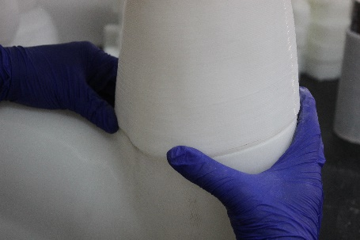

***Figure 21: Before applying the Dimengel, ensure that the parts fit firmly together.***

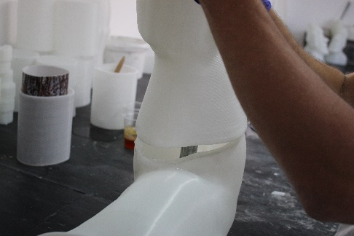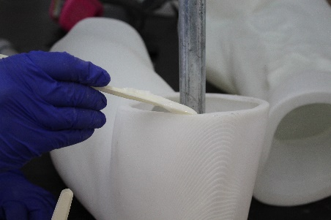

***Figure 22: Apply raw Dimengel onto connection area.***

***Figure 23: Attach the two parts together and cure with the UV flashlight.***

# SUMMARY

To produce large and impressive models for visual communication, 3D-printed models often require small fixes that include filling and cutting holes, removing functional parts and combining several printed parts into a single, larger model.

This document includes the best practices, guidelines and tips that we have learned from our own experience and from the experience of Massivit customers. We hope that you find this document beneficial.

For further technical questions about finishing a model, please contact your Massivit support representative or [support@massivit.com](mailto:support@massivit.com).

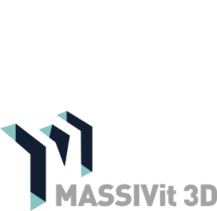

11 Pesah Lev St., Lod 712936. Israel | Tel: +972-8-6519486 | Fax: +972-8-6900758

[www.massivit.com](http://www.massivit.com) | [info@massivit.com](mailto:info@massivit.com)

© 2017 Massivit 3D Printing Technologies Ltd. All rights reserved. Massivit 3D, GDP Gel Dispensing Printing, Massivit 1800 and the related logos and slogans are trademarks of Massivit 3D Printing Technologies Ltd. All brand names are the property of their respective owners and may or may not be trademarked.